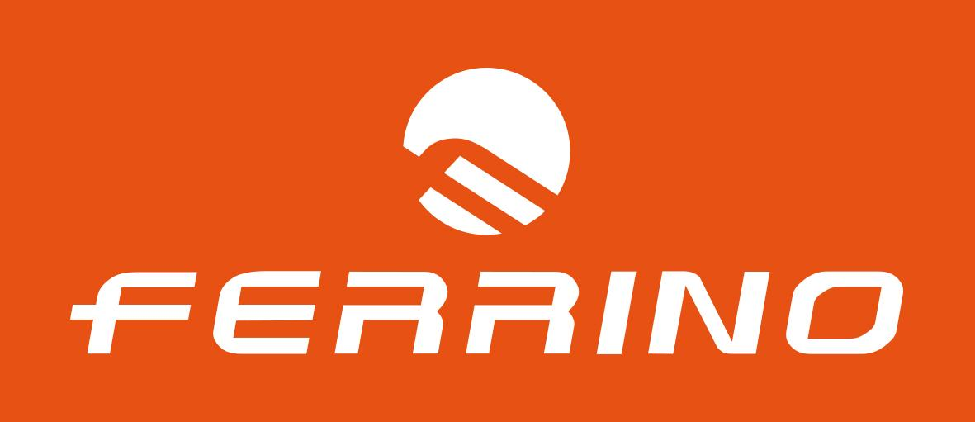
PRESS RELEASE

SCILLA TONETTI, SECOND WOMAN CLASSIFIED AT TOR 2018
A success for the Ferrino Women Team

Scilla Tonetti, second classified at the Tor des Géants®, tells her race, her journey, that started on Sunday and finished Thursday after 330 km.
We meet her together with Anna Ferrino, CEO of the company, with whom Scilla has been running for years, and together with whom was born the passion that in the last two years has led to the formation of a team of female athletes, the Ferrino Women Team (#FerrinoWomenTeam), a real "pink touch" at the Tor des Géants®.
"I can not believe it yet - says Scilla, born in '75 in Varese - because this result has amazed me. It has been a TOR marked by a slow start, reasoned, with much effort and planning, sleeping only an hour and a half during the entire race. Unfailing was the assistance of my sister and my friend, but also the support of the whole team, the union with the traveling companions Alice Modignani Fasoli, Luisa Balsamo, Sonia Sanchez and Noelia Herrera. And let's not forget Cristian Caselli, the only man on the Ferrino trail runners team ".
Scilla Tonetti lasted almost 96 hours, spent between sleepless nights and moments of difficulty, chasing the head of the TOR, where the effort has often been repaid by the beauty of dawn and the infinity of landscapes at altitude .
"It's really an honor - says Anna Ferrino - to see today the results of a project started last year on the sly, as a challenge for our brand and for the girls themselves. Geto to the women's podium means to carry out what we have always believed in, namely the fact that even very harsh enterprises, like those of the TOR, can be successfully experienced by women who embody in the races that are typical of their character, that is patience, resistance, self-denial and constancy. The friendship act with Jamie Aarons tells the spirit of the project, because crossing the finish line hand in hand with an opponent is a great gesture of female fair play ".
An ambitious project, the one of the Ferrino Women Team, which is about to expand and become more and more international, enhancing the existing excellences and aiming for the best for the TOR's tenth anniversary.
"I only realized now - says Scilla - that in front of the second place there is the first ... And who knows, next year I'm going to improve!".

