TORX® charity and environmental bibs: the "Aosta Valley for Ukraine" fund chosen as the main recipient
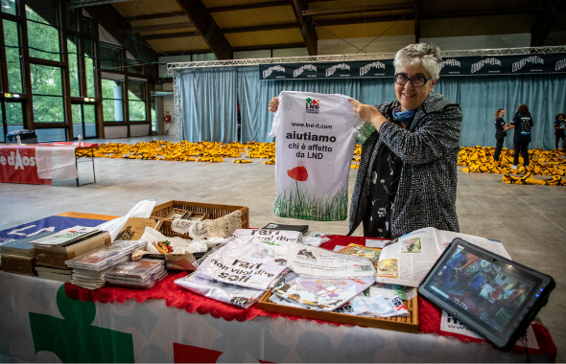
Charity bibs - Photo by Davide Verthuy - DOWNLOAD HERE

Thursday, 24th March 2022 - The charity and environmental bibs for the TORX® circuit races have only been on sale for a couple of days but they're already going like hot cakes. The sale will remain open at www.100x100trail.com until 30 June or until all the numbers are sold.

This year, VDA Trailers have decided to donate the proceeds of the 20 charity bibs for TOR330 - Tor des Géants® to the "Valle d 'Aosta for Ukraine" fund, set up by the Valle d'Aosta Community Foundation and the Valle d'Aosta Solidarity Coordination in partnership with the Board of the Valle d'Aosta Regional Council and the Permanent Council of Local Authorities, with a collective, coordinated solidarity action in response to the humanitarian crisis linked to the war in Ukraine.

"We have decided to support the efforts of the Valle d'Aosta community in ensuring the most appropriate reception for those fleeing the war, and in driving forward actions to support the Ukrainian people as a network, together with other organisations outside the Valle d'Aosta", explained Alessandra Nicoletti and Paolo Griselli, representatives of VDA Trailers. The first part of the contribution, given the great adhesion registered in the first hours of the bib sales, has already been paid into the fund.

“It's always great when two worlds come together,” said Pietro Passerin d'Entréves, President of the Valle d'Aosta Community Foundation. "In this case, the voluntary sector and the sports community. In a way, it's kind of the opposite of war. It's a show of solidarity - all of us working together in a fundraiser that will be concrete and targeted. A fundraiser that starts in our mountains but looks around at what's happening in an increasingly interconnected world, especially the tragic consequences of a humanitarian crisis".

The proceeds of the 20 TOR130 - Tot Dret chairty bibs on the other hand will be donated to LND Famiglie Italiane ONLUS, an organisation set up in 2011 to help combat Lesch-Nyhan syndrome, an extremely rare disease that affects children, preventing them from walking, moving freely and controlling their actions. LND is always there at the start of the TOR with "I maratonabili", an initiative set up to ensure success in a challenge more important than any competition - to give children with disabilities the chance to experience all the fun and excitement of a sporting event.

Finally, the 10 environmental bibs assigned to the TOR330 - Tor des Géants® will help fund EcoloTOR, a project that supports any activity aimed at reducing the environmental impact of the TORX®, from energy saving to waste collection, together with ongoing research and analysis in the Valle d'Aosta area on race days; activities that have also been carried out in the past, in accordance with the Courmayeur Charter for sporting events with low environmental impact, of which VDA Trailers is a founder and signatory along with the Italian Ministry of the Environment.

TORX® eXperience is a new circuit of competitions united by the TORX® values and experience, with breath-taking views as the reward for all the effort, passion, sharing and connection that provide such enduring memories. And TORX® has now created a new concept: PAX- race numbers reserved exclusively for those who finish a TORX® eXperience race. If you're a finisher you're in Heaven's waiting room with a race number for the TOR330 - Tor des Géants®. With the new PAX system you’re a step nearer to the ultimate challenge - running in the legendary Tor des Géants® the following year without going through the draw.
A limited number of PAXs for the TOR 330 will be available each year, reserved exclusively for those who finish a TORX® eXperience. This year 200 PAXs will be available for finishers of the TOR130 – Tot Dret and 100 PAXs for finishers of the GTC100, regardless of their position in the rankings.
As usual, registrations must be done online at 100x100trail.com. Regulations and further information are available on the TORX® website.

PRESS OFFICE TORX®

Erica Motta - Head of Communication
M + 39 347 1342003
e.motta@vdatrailers.it

Massimiliano Riccio - PiùPress
M +39 347 9179915
press@vdatrailers.it

